**Exercise – 1.2**

Given the values of R, L, C and the supply voltage V of a series RLC circuit, write a MATLAB program to

1. Find the resonant frequency and to obtain the current, power and voltage drop across the various elements under resonance.
2. Plot the resonance curve (*i* vs. *f*) by varying the supply frequency within a range of +/- 25 Hz from the resonant frequency. Repeat (ii) for different values of L and C keeping LC constant. Observe and comment on the nature of the curve.

Choose R = 30 Ω, C = 80 µF, L = 80 mH, and supply voltage = 150V.

**M-code:**

% Ex-1.2 (Circuit Theory)

% Sambhav R Jain

% 107108103

clc;

clear all;

close all;

fprintf('Ex-1.2 Resonance in a series RLC circuit\n');

fprintf(' - Sambhav R Jain (107108103)\n\n');

V=input('Enter the supply voltage (in V): ');

L=input('Enter the value of inductance L (in H): ');

C=input('Enter the value of capacitance C (in F): ');

R=input('Enter the value of resistance R (in ohm): ');

% Resonance occurs when Xl=Xc

fr=1/(2*pi*sqrt(L*C));

disp('Resonant frequency (in Hz): ');

disp(fr);

Xl = L*2*pi*fr;

Xc = 1/(C*2*pi*fr);

I=V/(R+1j*Xl-1j*Xc);

disp('Current (in A): ');

disp(abs(I));

Vr=I*R;

Vl=I*1j*Xl;

Vc=I*-1j*Xc;

disp('V_r (in V): ');

disp(abs(Vr));

disp('V_l (in V): ');

disp(abs(Vl));

disp('V_c (in V): ');

disp(abs(Vc));

Pr=Vr*I*1e-3;

Pl=Vl*I*1e-3;

Pc=Vc*I*1e-3;

disp('Real power dissipated across R (in kW): ');

disp(Pr);

disp('Reactive power across L (in kVAr): ');

disp(Pl);

disp('Reactive power across C (in kVAr): ');

disp(Pc);

for L=60e-3:10e-3:100e-3

C=(1/(2*pi*fr)^2)/L;

m=1;

for f=fr-25:1:fr+25

Xl = L*2*pi*f;

Xc = 1/(C*2*pi*f);

I(m)=V/(R+j*Xl-j*Xc);

m=m+1;

end

f=[fr-25:1:fr+25];

plot(f,I);

hold on;

grid on;

title('Resonance curve');

xlabel('Frequency (Hz) ----->');

ylabel('Current (A) ----->');

% legend(sprintf('L = %d mH',L*1e3));

end

**Terminal Display:**

Ex-1.2 Resonance in a series RLC circuit

- Sambhav R Jain (107108103)

Enter the supply voltage (in V): 150

Enter the value of inductance L (in H): 80e-3

Enter the value of capacitance C (in F): 80e-6

Enter the value of resistance R (in ohm): 30

Resonant frequency (in Hz):

62.9115

Current (in A):

5

V_r (in V):

150

V_l (in V):

158.1139

V_c (in V):

158.1139

Real power dissipated across R (in kW):

0.7500 - 0.0000i

Reactive power across L (in kVAr):

0.0000 + 0.7906i

Reactive power across C (in kVAr):

-0.0000 - 0.7906i

**Waveforms:**

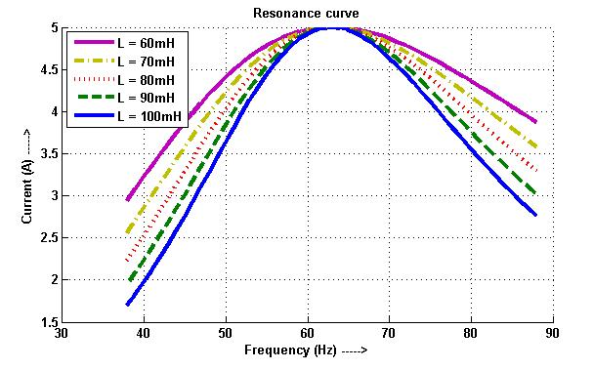

**Results:**

Hence the resonant frequency for the given values of R, L and C is found and the resonance curve is plotted. Now, the values of L and C are varied keeping LC constant. Thus resonance is found to occur at the same frequency, however the envelope is found to shrink as L is increased. In other words, the selectivity of the circuit improves as the bandwidth reduces.